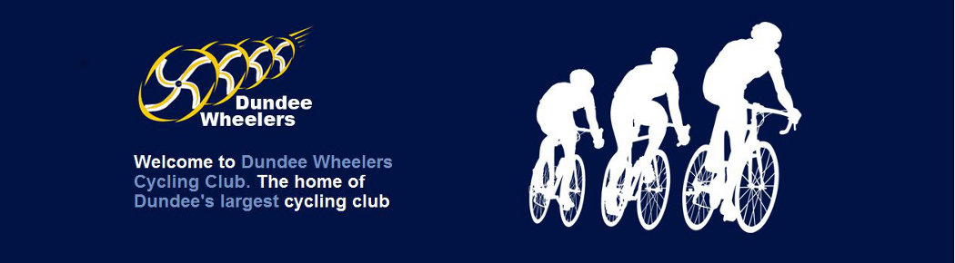
Annual Presentations Nominations 2022

Please tick the box for who you want to vote for in the category below.

All votes to be submitted to the club secretary no later than 18th November, either by emailing your completed nominations form to secretary@dundeewheelers.co.uk or by handing in your form.

All Wheelers members in the current year are eligible to vote.
Club Member(s) of the Year
The member who has best served, and promoted the club in any capacity throughout the year.

Gary Kilcullen
Organizing and supporting the Group 3 Saturday club runs.

Steve Knight
For supporting and encouraging club runs and riders, training and event advice and unofficial tour guide duties.

Dave Stewart
For promoting, supporting and encouraging weekend runs and new members.
The Bob Kilhooley Most Improved Rider Award
The member who has improved, in any discipline, in the last year.

John Cunningham

Ricky Davidson

Dave Marshall

Helen Wall

Sportive Award
The male and female members who completes the most miles in any UK based Sportives/ Reliability Trials / Audaxes in the year. If you wish to be considered for this award please complete the details below. Note the mileage logged must be the official published mileage of the event (not what was on your Garmin and certainly not including any detours )
Date | Event | Mileage
 | Total Mileage

